F. EXAMPLE PROJECTS WHICH BEST ILLUSTRATE PROPOSED TEAM'S
QUALIFICATIONS FOR THIS CONTRACT
(Present as many projects as requested by the agency, or 10 projects, if not specified.
Complete one Section F for each project.)
_____________________________________________________________________________________________________________________
- EXAMPLE PROJECT KEY NUMBER: 3

- TITLE AND LOCATION (City and State): Sheep Mountain Uranium Project

- YEAR COMPLETED - PROFESSIONAL SERVICES: 2011

- YEAR COMPLETED - CONSTRUCTION (If applicable): 2011

23a. PROJECT OWNER'S INFORMATION - PROJECT OWNER: Energy Fuels Resources (Formerly Titan Uranium)

23b. PROJECT OWNER'S INFORMATION - POINT OF CONTACT NAME: Frank Filas

23c. PROJECT OWNER'S INFORMATION - POINT OF CONTACT TELEPHONE NUMBER: 303 974 2140

- BRIEF DESCRIPTION OF PROJECT AND RELEVANCE TO THIS CONTRACT (Include scope, size, and cost):

The Sheep Mountain Project is located approximately 8 miles south of Jeffrey City, Wyoming and is comprised of 179 unpatented mining claims comprising approximately 3,205 acres and approximately 640 acres of State of Wyoming lease (i.e., ML 0-15536 located in Section 16, Township 28 North, Range 92 West). There are approximately 630 acres of private lease lands in Section 20, 29, 31, 32, and 33. Refer to Figure 4.2, Claim Map. The combined mineral holdings comprise some 4,475 acres.

Through February of 2011, BRS represented Titan Uranium as the Project Engineer of the Sheep Mountain Project. Responsibilities during this period included lead roles in the geologic evaluation and mineral resource estimation, mine design, and permitting at both state and federal levels. In addition, BRS was responsible for the design and construction management related to ongoing reclamation obligations including the closure and reclamation of the Sheep I to Sheep II haul road, demolition of the mine shops, capping of the Sheep underground mine shafts, general site clean-up and stabilization, and establishing and maintaining storm water control. (See Photos)

The Sheep Mountain Uranium Project includes the Congo Pit, a proposed open pit development, and the re-opening of the existing Sheep Underground mine and includes the processing of mined materials via an on-site heap leach facility. Following, completion of the project feasibility study for the project in February, 2012, Titan Uranium was acquired by Energy Fuels Resources (EFR). BRS has provided limited services to EFR since the acquisition, by request, but without a contract, including portions of the BLM Plan of Operations revision, preparation of the Mine Permit 381C annual report, and a support role with respect to environmental monitoring.

Specific project roles completed by BRS during the period of October, 2009 through February, 2011 include:

- Land and Surface Ownership
  - Reviewed mining claims, corrected, mineral fillings as needed, and staked and filed new claims.
  - Assisted in the negotiations for purchase of the heap leach area.
  - Met with surface owners with respect to leases and access.

- Surveying and Mapping
  - Established State Plane survey control.
  - Set control for and coordinated aerial mapping.
  - Developed digital terrain model (Refer to Figure 1 Existing Conditions).

- Geology and Mineral Reserves
  - Completed 3D geologic model.
  - Completed overburden sampling re LQD guidelines.
  - Rectified historic mine mapping in 3D space.
  - Estimated mineral resources and reserves.

- Mine Engineering
  - Completed mine design and sequencing (Refer to Figure 2).
  - Completed mine reclamation design emphasizing geomorphic reclamation (Refer to Figure 3).
  - Completed mine feasibility.
  - Completed earthworks portion of heap and processing facility design.

- Permitting
  - Coordinated environmental baseline studies for both federal and state permitting.
  - Managed LQD mine permit revision.
  - Managed preparation of the BLM Plan of Operations.
  - Assisted with the preparation of USNRC Source Materials License.

BRS’ ongoing project role may include:

- Response to LQD draft comments on the mine permit revision for the Congo pit and Sheep underground mines.
- Support of ongoing environmental baseline data collection.
- Preparation of SEO permits for holding ponds.
- Preparation of maps and figures.
- Site engineering and layout related to mine facilities.

BRS’ ongoing project role will not include:

- Project Management and/or overall project engineering.
- Representation of EFR in any negotiations with permitting agencies, state of federal.
- Preparation of heap/mineral processing facility design, operational, or reclamation plans.

AML’s McIntosh Pit Project is located south of the planned mining and mineral processing facilities associated with Sheep Mountain and will not conflict with the planned operation. The site eligibility has been determined subject to EFR contributing funds equivalent to their bond obligation for the northern portion of the pit. All data which has been made public relative to the Sheep Mountain Project should be available to AML for this project.

Figure 1 - Sheep Mountain Existing Conditions

Figure 2 – Sheep Mountain During Mine Operations

Figure 3 – Sheep Mountain Mine Reclamation

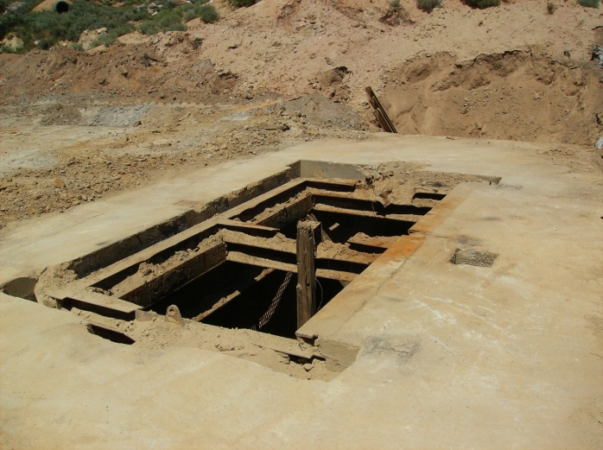
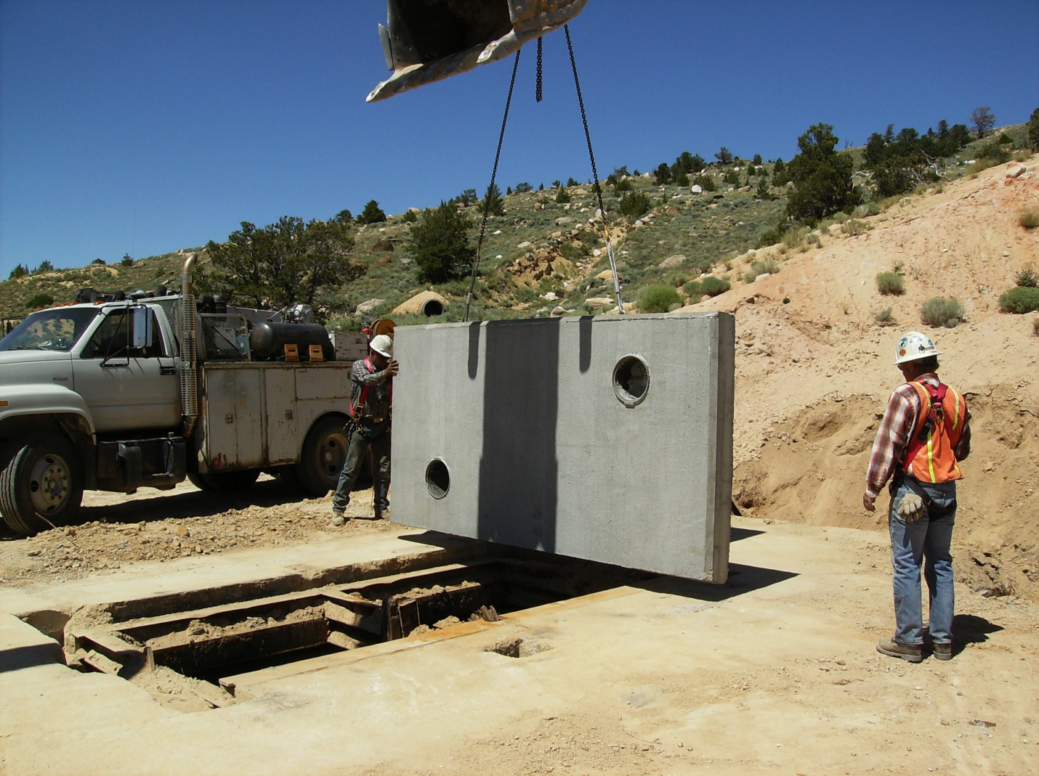

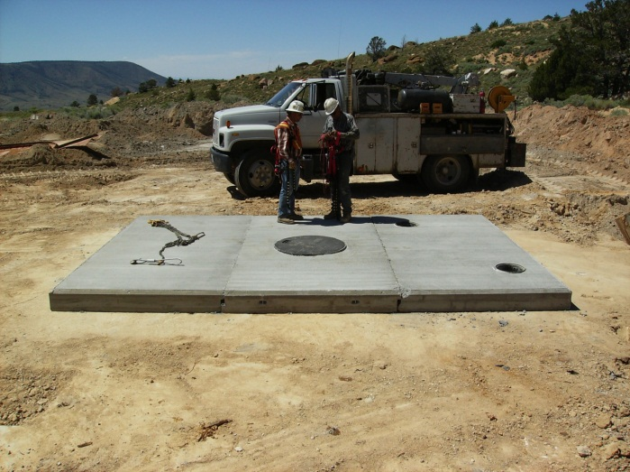
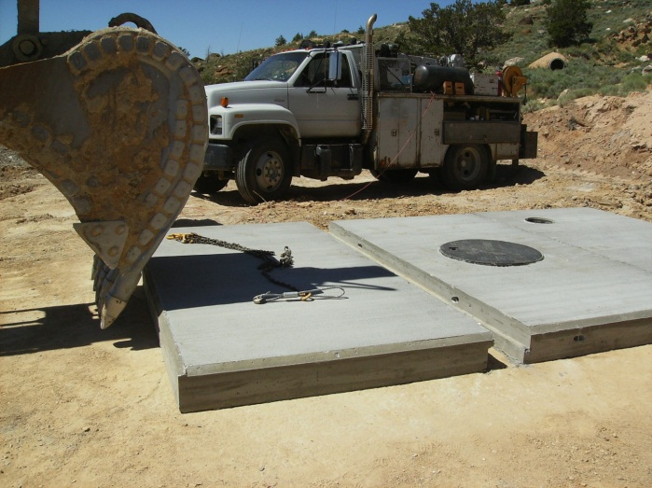

Placement of Sheep II Shaft cap with locking manhole access.

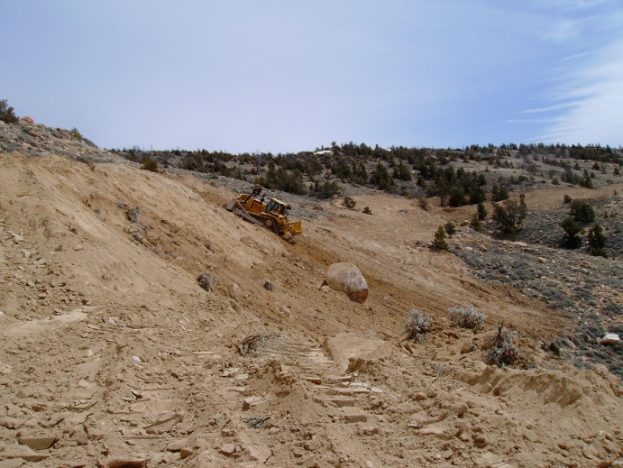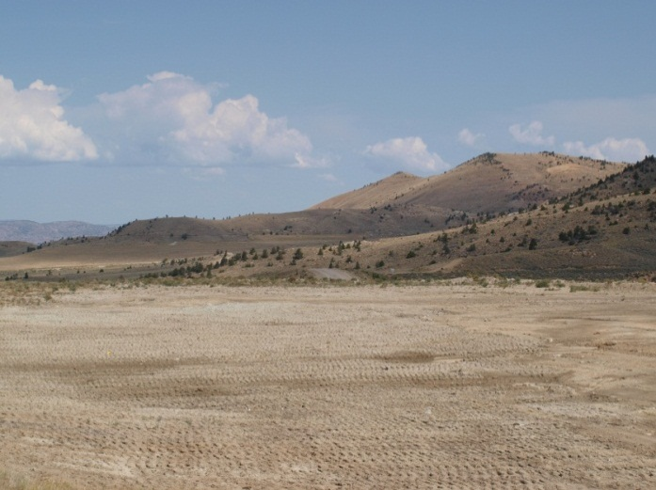

Reclamation of Sheep I to Sheep II haul road. Reclaimed Mine Shop area.

- FIRMS FROM SECTION INVOLVED WITH THIS PROJECT
(1) FIRM NAME | (2) FIRM LOCATION (City and State) | (3) ROLE
BRS Inc. | Riverton, Wyoming | Project Design and Management

