F. EXAMPLE PROJECTS WHICH BEST ILLUSTRATE PROPOSED TEAM'S
QUALIFICATIONS FOR THIS CONTRACT
_____________________________________________________________________________________________________________________
- EXAMPLE PROJECT KEY NUMBER: AML 16A-III John Gunnel Project

- TITLE AND LOCATION (City and State): Gas Hills, Wyoming

- YEAR COMPLETED - PROFESSIONAL SERVICES: 2006

- YEAR COMPLETED - CONSTRUCTION (If applicable): 2006

23a. PROJECT OWNER'S INFORMATION - PROJECT OWNER: Wyoming AML

23b. PROJECT OWNER'S INFORMATION - POINT OF CONTACT NAME: Vicky Zimmerman, AML Project Officer

23c. PROJECT OWNER'S INFORMATION - POINT OF CONTACT TELEPHONE NUMBER: 307 335-6947

- BRIEF DESCRIPTION OF PROJECT AND RELEVANCE TO THIS CONTRACT (Include scope, size, and cost): Follows

- FIRMS FROM SECTION INVOLVED WITH THIS PROJECT

(1) FIRM NAME | (2) FIRM LOCATION (City and State) | (3) ROLE
BRS Inc. | Riverton, WY | Site Investigation, Design, CM

A brief Project description follows:

The John Gunnel project included the reduction of a remnant highwall from a previous reclamation project. The reclamation design included the removal the Frazier Lamac Haul road and the incorporation of a series of small surface water attenuation impoundments to control surface water flow and minimize erosional impacts upon adjacent reclamation. The cut material from the haul road was used as fill for the highwall reduction. This approach minimized the disturbance of reclaimed and native lands adjacent to the highwall, and had the added benefit of reclaiming the haul road to the pre-mine surface. The surface water attenuation impoundments were designed for sediment and erosion control and had the added benefit of providing a surface water source for wildlife and livestock. Upon completion of construction, BLM assumed the rights to the surface water impoundments. The John Gunnel project also included provisions for the establishment of a historical monument which documents the original discovery of the Gas Hills Uranium Mining District.

KEY PROJECT REQUIREMENTS:
- Site investigation and design
- Construction Management
- Identification of surface and subsurface materials
- Radioactive waste disposal and clean-up verification
- Earthworks and surface water hydrologic design
- Permitting and eligibility determination

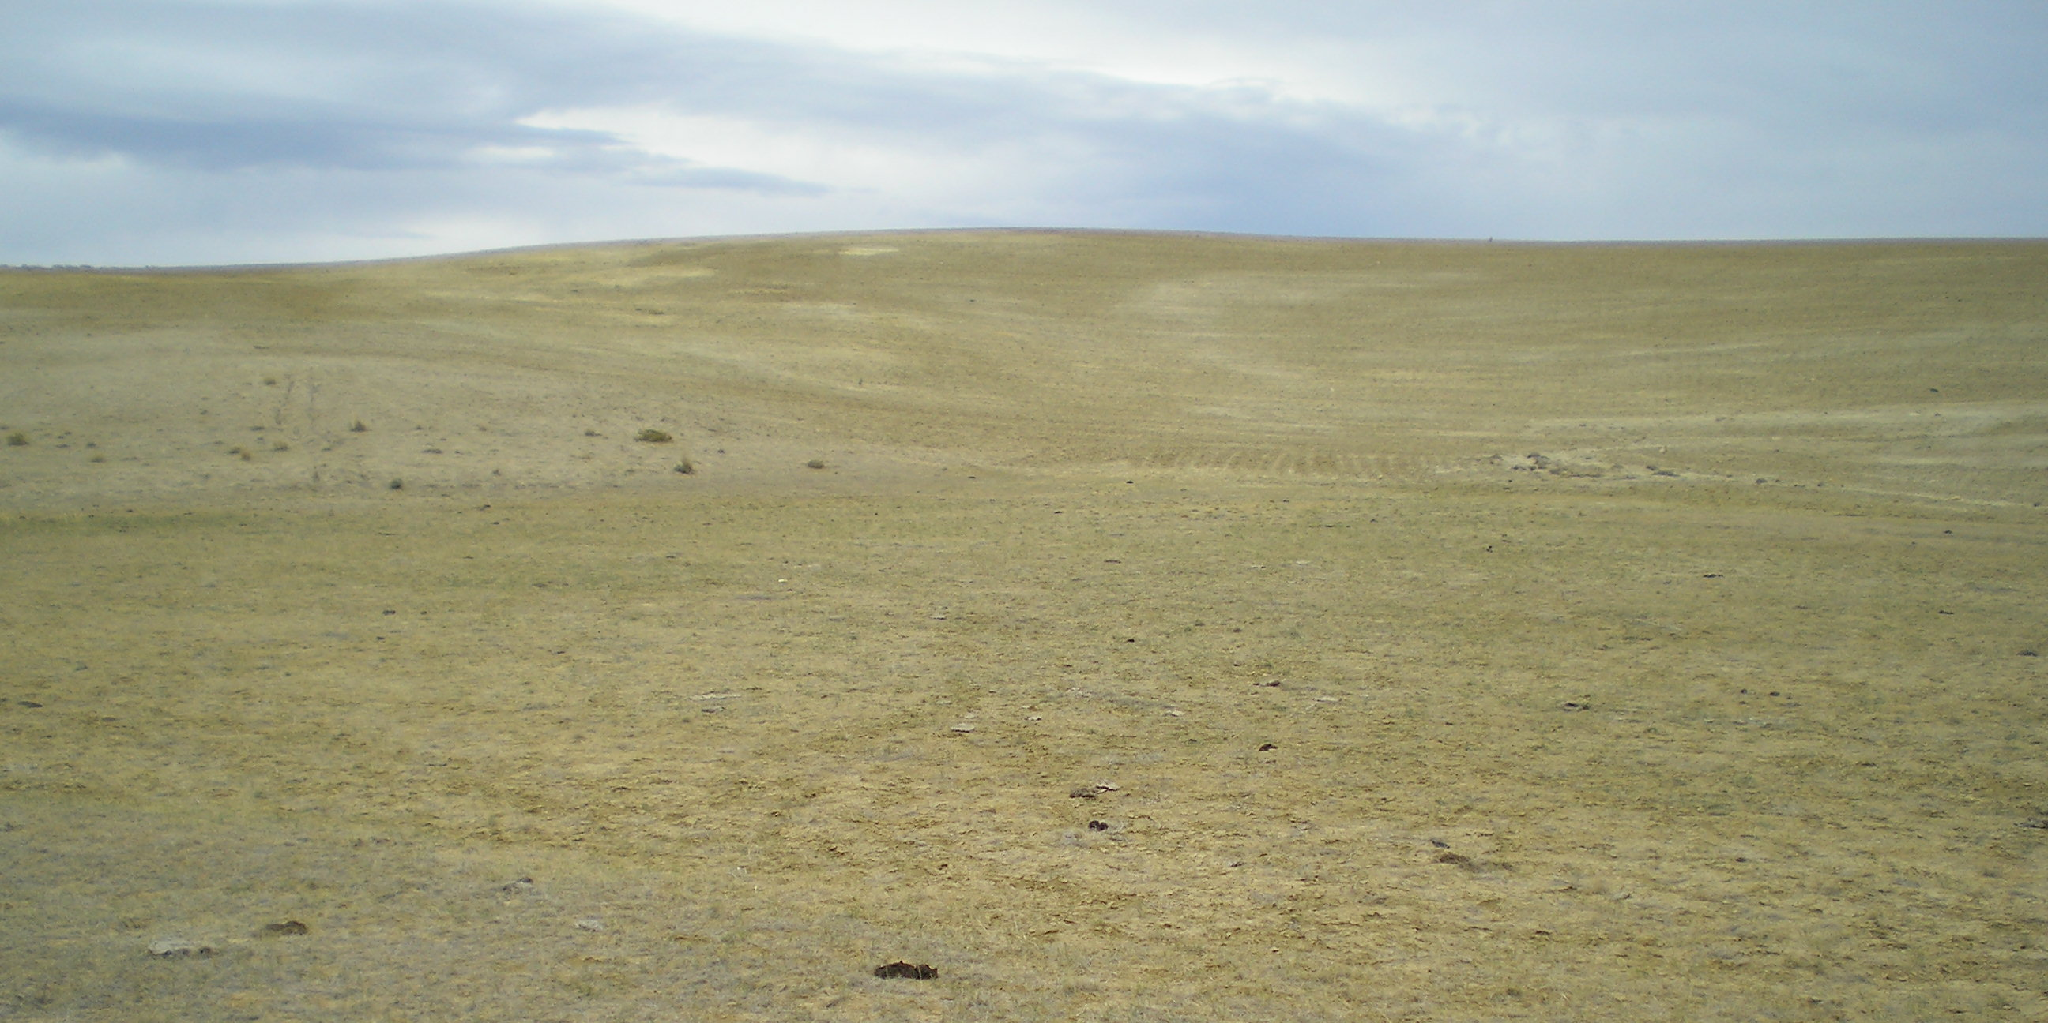
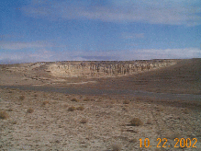
Before Construction: After Construction:

